Diploma Project Synopsis Guidelines
1. Title Page
- Include project title, names of all group members (with enrollment numbers), department, guide name, institute name, and academic year.
- Place institute logo centrally.
2. Certificate Page
- Official statement certifying project synopsis completion, signed by project guide and H.O.D.
3. Acknowledgement
- Express grattitude appreciation to all those who gave important contribution for completion of seminar report.
4. Abstract
- Concise (max 150 words) summary of the project’s core objectives, relevance, and expected outcome.
5. Table of Contents
- Section headers with corresponding page numbers in tabular format.
6. Introduction
- Briefly explain the problem statement, overall context, and technology relevance.
7. Literature Survey
- Summarize minimum 5-6 referenced research papers, patents, or academic sources.
- Include a comparison with existing solutions or approaches.

8. Problem Definition
- Mention problem definition about the selected entitled seminar
9. Existing System
- Outline currently available systems, their working, and limitations or drawbacks.
10. Proposed System
- Clearly define project innovation, technical improvements, features, and how it overcomes existing system limitations.
11. Objectives
- State the main aims and specific goals of the project.
12. Scope
- Specify the boundaries, constraints, and potential applications of the project.
13. Methodologies
- Detail system architecture, diagrams (block, flowchart, ER/DFD/UML), and process flow.
14. Technology Used
- Clearly mention front-end/back-end choices, frameworks/libraries/platforms, and technical advantages.
15. Resources, consumables Requirements
Minimum hardware and software specs required to run/implement the project.
16. Conclusion
- Summarize achievements, practical value, and project success indicators.
17. References & Bibliography
- Adhere strictly to IEEE/APA format.
- Minimum 10 references from journals, standards, patents, or reputed sources.

18. Action Plan
- Sequential list of activities with probable dates of completion

Formatting Instructions
- Font: Times New Roman, Title 14pt, Section Heading 12pt Bold, Main Content 12pt.
- Margins: 1 inch all sides.
- Line spacing: 1.5.
- Minimum 12-15 pages (excluding front matter and appendix).
- Diagrams, Images, figures and graphs captioned and cited at bottom.
Example:-
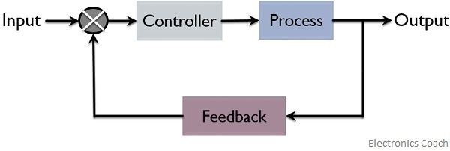
Figure No. 1.1 - Close loop production system
- Table captioned and cited at top.
Example:-
Table No. 2.1 – Comparison Chart
Type | Quantity | Flexibility | Cost
Job | Very Low | Very High | High
Batch | Medium | Medium | Medium
Mass | High | Low | Low
Continuous | Very High | Very Low | Very Low

- Spiral bound hard copy to be submitted.
- Prepare a project demo presentation alongside report.

